Business Intelligence Data Analytics Report

Electricity Net Installed Capacity

(Solar, Combustible Fuels, Geothermal and Nuclear)

**Executive Summary:**

This research entails the potential of using business intelligence tools to analyse the energy trends of the world. Through this research, we hope to determine the direction of the trend when it comes to the energy sector. For the analysis, the dataset is obtained from the United Nations Database. The dataset entails the year, country and the quantity of net installed capacity of Solar Power, Geothermal Power, Nuclear Power, and Combustible Fuels from 1980 to 2018.

Analysis shows that the world is generally moving towards cleaner methods of power generation. We see a strong uptrend in the Solar and Geothermal sector, whereas a downtrend in the combustible fuels sector. The trend in the Nuclear Power sector seems to be increasing at a stable rate, since not many countries currently have the capacity to have nuclear power.

Overall, countries like US, China, India, Germany, Japan, tend to have the most net installed capacity.

**Key Findings:**

Solar Power shows a strong uptrend, and China appears to be leading the race in Solar Power net installed capacity, followed by Russia, Germany and so on. Combustible fuels is now starting to decline due to the shift towards cleaner energy sources, but there is still work to be done, as China, US, India, etc still use combustible fuels to a great extent. Geothermal and nuclear energy are increasing at a stable rate.

Table of Contents

1. Introduction 4

2. Trends in Business Intelligence 5

3. Business Intelligence in Various Domains 5

4. Scope for Research: 6

5. Methodology 6

6. Analysis 7

6.1 Solar Power 7

6.2 Combustible Fuels 9

6.3 Nuclear Power 11

6.4 Geothermal Power 13

7. Discussion 16

8. Conclusion 17

9. Recommendations 17

10. Future Scope 17

11. References 18

# Introduction

With the explosion in the transfer and storage of dataset volume, analysing and interpreting such data is becoming more and more important. Business Intelligence tools helps organisations, firms, businesses, economies analyse large amounts of data to draw quick and informative results for effective decision making. It is made up of softwares, techniques and services which transforms raw data into useful insights that lead to efficient and effective decision making (Pratt & Fruhlinger, 2019).

One no longer needs a specialized analyst to handle, clean and analyse data. Business intelligence tools make it very easy to do the same for any business without any prior skill or knowledge. This is revolutionary since data is now the most valuable resource in the world. These tools are easy to use, flexible and effective. Business intelligence is a wider term and contains numerous processes and techniques such as Data Mining, Reporting, Performance metrics, Data warehousing and so on (tableau, 2019).

The energy sector is indeed the backbone of any economy (Bhattar, 2019). It is almost impossible to live these days without electricity. But these sources are also harmful for the environment. Therefore, there is a need for countries or organisations to shift towards cleaner, environment friendly sources of power generation. Thus, it is important to study the trends in electricity production across the world. In this study, we research on the net installed capacity of Solar Power, Geothermal Power, Combustible Fuels, and Nuclear Power from 1980 to 2018.

The purpose behind this study is to provide useful and conclusive insights about the workings of the energy sector, so that policy makers can make wise decisions about the same, and countries can easily shift towards cleaner sources of power in a smooth manner.

# Trends in Business Intelligence

With the exponential rise in the Big Data industry, business intelligence is picking up pace, especially in the last few years. The landscape of business intelligence is constantly evolving and involving more and more techniques and softwares (Frankenfield, 2019). Some of the most famous business intelligence tools are as follows:

1. Artificial Intelligence:

Artificial Intelligence, Machine Learning, Deep learning, etc are techniques which are revolutionizing the way humans deal, analyse and interpret data (Kumar, 2019). Artificial intelligence is concerned with teaching the machine to learn and analyse data by itself without the involvement of humans. Business intelligence is now using AI algorithms or neural networks to analyse data for businesses in a manner that saves time, money and effort. These algorithms analyse the dataset in a detailed manner without any human interference (Durcevic, 2019).

1. Embedded Analytics:

Embedded analytics is the process of integrating or combining analytics capability with the natural workflow of business intelligence users (Rai, 2019). In this manner, it removes the requirement for individuals to switch between different screens to get different type of results. Thus, this saves a lot of time and effort for businesses and organisations, and ensures a smooth working of the same (Adair, 2016).

1. Increased Revenue:

Using such technologies leads to a rise in the revenue stream, as decisions are now made in a faster and easier manner using better information (2U, 2019).

1. Eliminates waste:

BI technologies can point out areas which are or have been creating waste in the past. This helps businesses identify such areas and take corrective action (Strain, 2020).

With such wide benefits and applicability of using such technologies, more and more businesses and organisations are integrating such technologies in their operations and businesses (Micro Strategy, 2017).

# Business Intelligence in Various Domains

With the growing adoption of business intelligence in innumerable fields of life and business, more and more industries are looking to adopt such techniques to compete in the economy. Some of the areas where business intelligence is creating noise are as follows:

1. Sports:

Even though its hard to believe but sports management often deals with large amounts of data. Making decisions about which players to draft, which to buy, which to play in a particular game are some of the key decisions made by a manager. This brings the need for business intelligence tools to analyse such data and provide useful insights, which can help a coach or a manager make effective decisions which might help win a game (Rangaiah, 2018). Performance monitoring is a very important area in sports under which business intelligence is used (Panintelligence, 2017). Thus, managers and leagues are hiring more and more sports scientists to develop strategies which can help significantly (Ward, Windt, & Kempton, 2019).

1. Banking and Finance

A Financial analyst has to regularly analyse and interpret historical data to make accurate predictions and invest accordingly. This analysis often takes a lot of time and effort. With business intelligence tools, this is made to be very easy and efficient. BI helps in providing concrete results from historical data, and helps in prediction of future prices, which can assist in effective decision making (sesame, 2017).

# Scope for Research:

The purpose of this study is to see the potential for business intelligence to be used while analysing and identifying trends in the energy sector. The power sector has undergone a drastic shift, wherein countries and organisations are trying to find newer and innovative ways to make electricity in a clean and environment – friendly manner. Analysing these trends is important for organisations and countries to make good decisions about the same.

Business intelligence techniques and tools can be adopted to analyse such trends and give useful information about the same. Such tools make the process much more feasible and easier, and make sure that conclusive results are formed in an efficient and effective manner. The research has the following objectives:

1. To identify the trends of Solar Power, Geothermal Power, Combustible Fuels, and Nuclear Power from 1980 to 2018. To then track the differences among these trends, and come up with concrete results to support a smooth transition towards cleaner energy sources.
2. To identify differences among 150 countries regarding trends in Electricity Production, and make customized decisions for each country.

# Methodology

This research is secondary in nature, and gathers data from the internet. The datasets used for analysis are obtained from the United Nations database, and contain the new installed capacity of Solar Power, Geothermal Power, Nuclear Power and Combustible fuels for the world between 1980 and 2018. This data is then analysed using SAP Lumira, which efficiently creates and provides useful insights into the energy sector.

# 6. Analysis

The study aims to find the trend in the net installed capacity of Geothermal, Combustible Fuels, Solar and Nuclear power plants across 150 countries and a time span of 38 years (1980 – 2018). Analysing such trends will help us make effective decisions and policies for the use of electricity across the world, and to follow UN’s Sustainable development goals.

## 6.1 Solar Power

We first look at the trends in electricity produced using solar Power Plants. For this purpose, we take the dataset which entails the Net Installed Capacity of Solar power across the world from 1980 to 2018. Analysing and visualizing the dataset we find the following results:

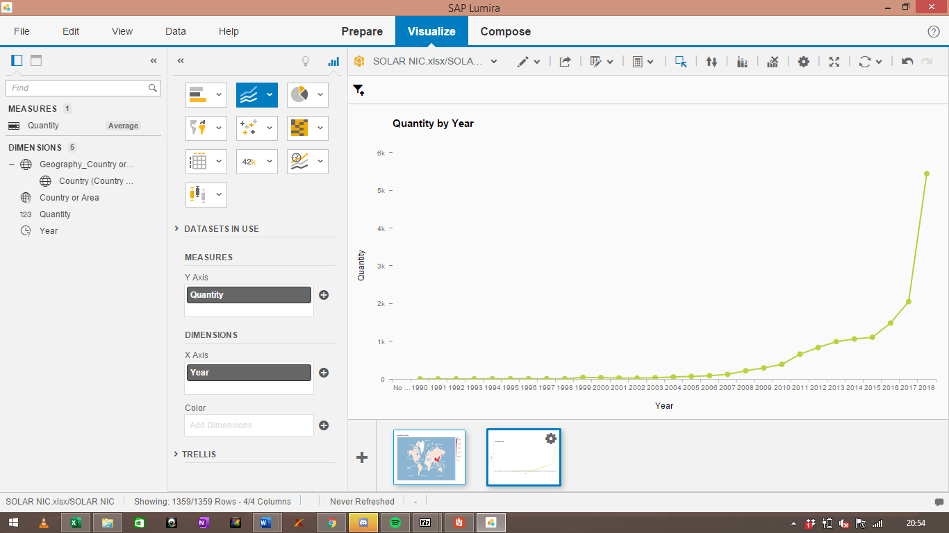

The above graph shows the trend in the average world Net Installed Capacity of Solar power plants from 1980 to 2018. We can clearly see that up until 2003, there was little to no movement in the solar power arena. But Solar power started gaining momentum from 2004 onwards and really picked up the pace after 2015, wherein we see the sharp increase. This is due to the tendency to adopt cleaner energy solutions recently, which has increased the demand for solar energy.

Now we focus on cross country analysis as follows:

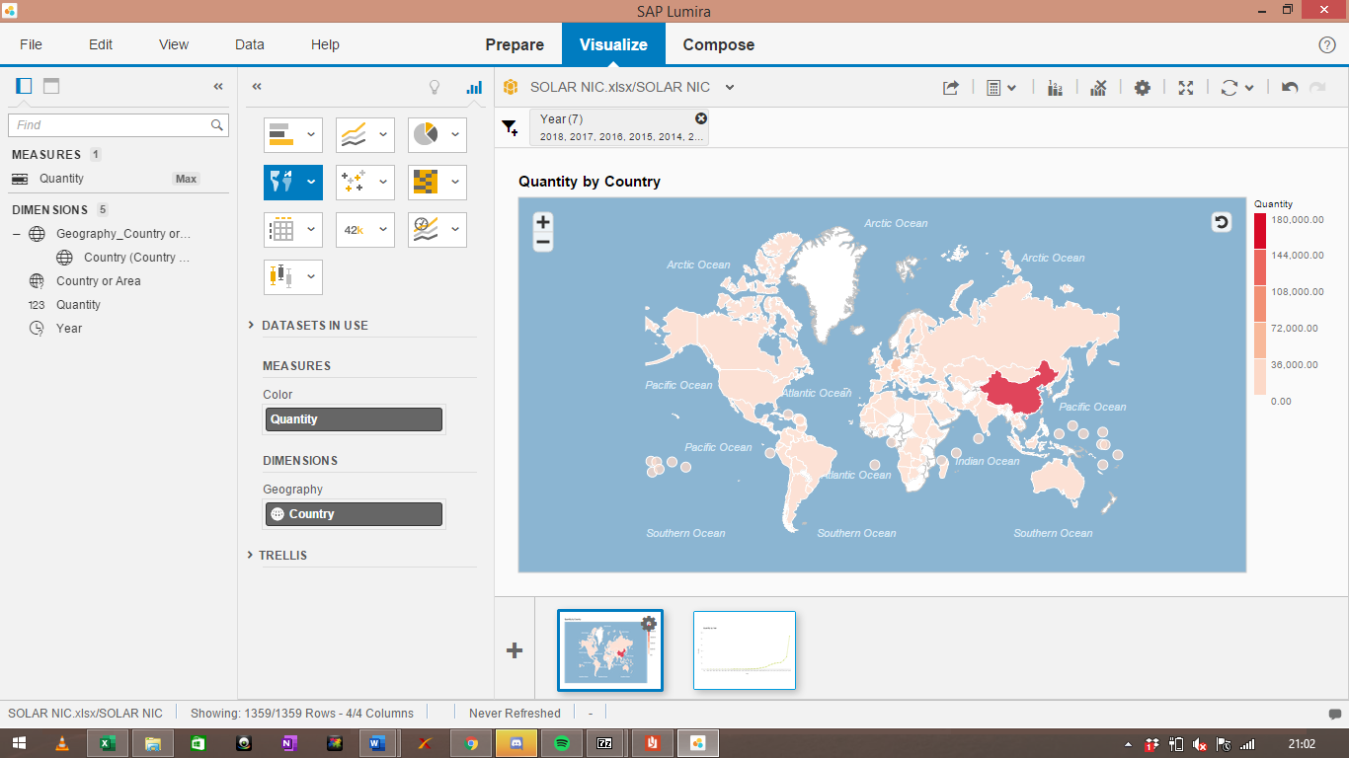

In the above map, the scale of net installed capacity is positioned on the right-hand corner in the form of sequential red. We see that China has the highest net installed capacity of solar power in the world, with the amount reaching 174,630 thousand kilowatts. US, Russia, India, Japan come after China. To get a clearer picture, we look at the following map:

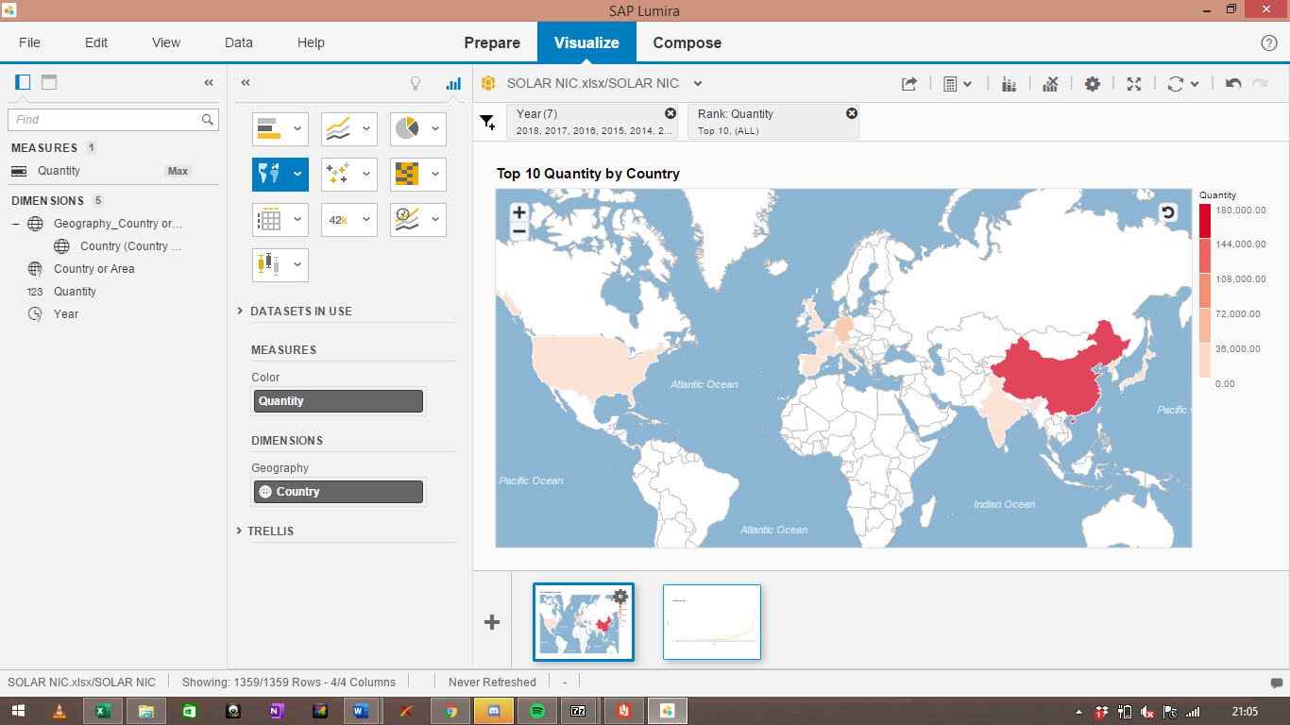

The above graph only shows the top 10 countries in the world in terms of quantity of net installed capacity, which are: China, US, Germany, France, Italy, Japan, India, Korea, UK, and Spain. China has the highest net installed capacity, followed by Germany, US and India.

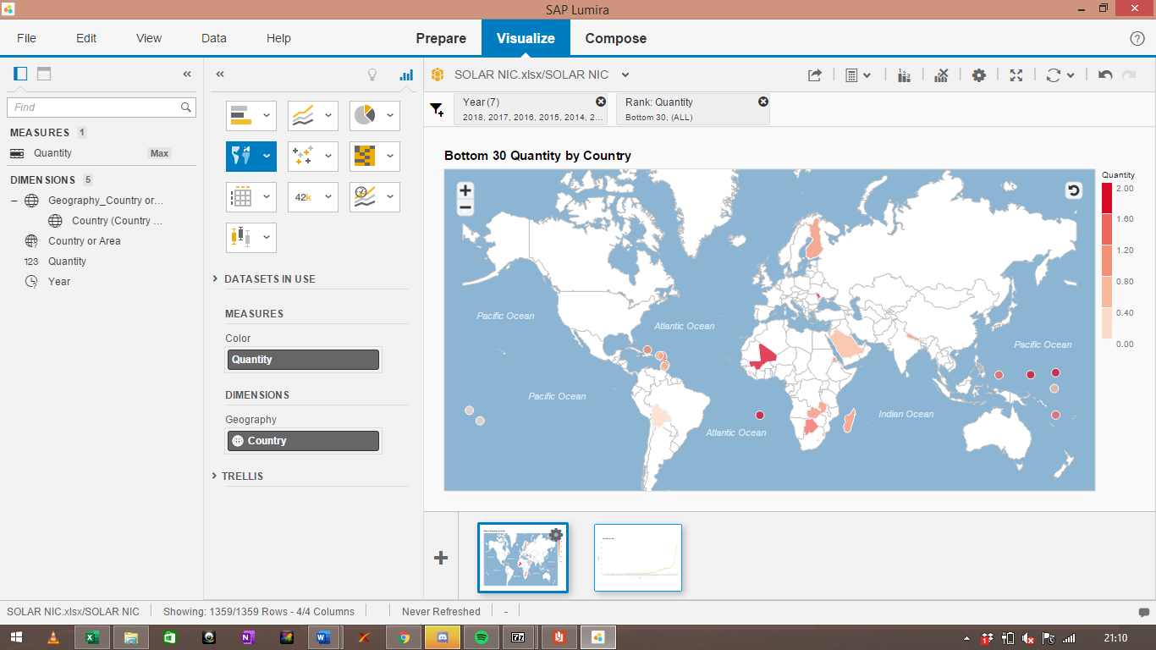

This map shows the bottom 30 countries in terms of quantity of solar power installed. Some of the countries with little to no solar capacity are Bolivia, Bhutan, Saudi Arabia, Nepal, and so on. These are the countries which need immediate attention, since they are still relying on harmful ways of producing energy.

## 6.2 Combustible Fuels

The author now wishes to draw attention towards the trend of combustible fuels to see whether the tendency to shift towards greener energy sources has been carried out or not. This is done in the following manner:

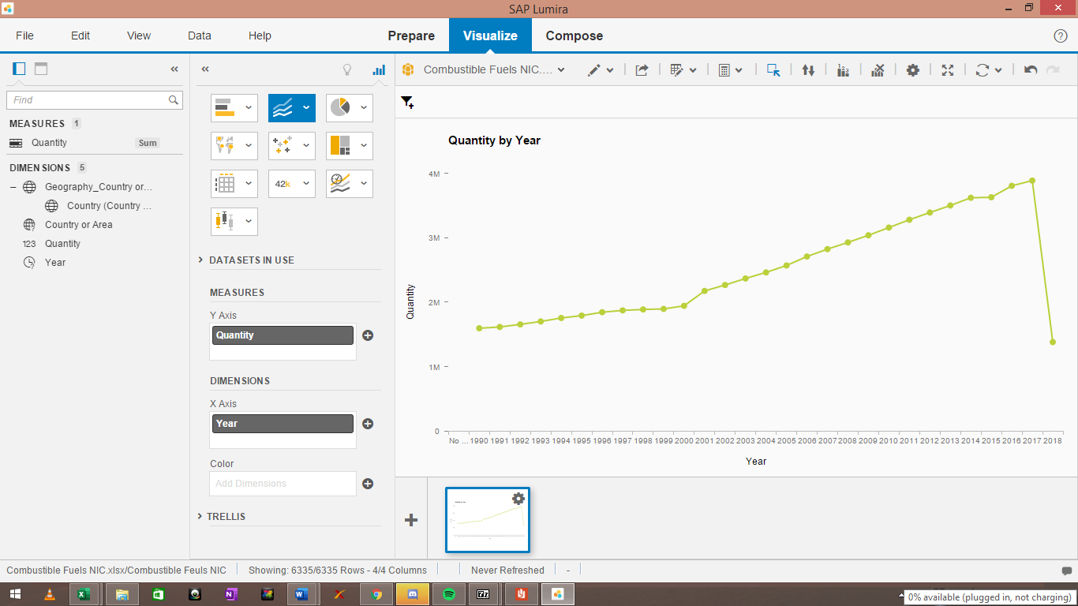

The above graph shows the trend of the total Net Installed Capacity of the world from 1980 to 2018. We can see that the installed capacity has been on an upward trend since 1980, but recently dropped significantly in 2018. This can be due to the fact that countries are now trying to go towards cleaner usage of energy. Combustible Fuels generate a lot of waste and harmful gasses, thus the demand and in turn the installed capacity has gone down significantly.

To look at differences across countries, we plot the following map:

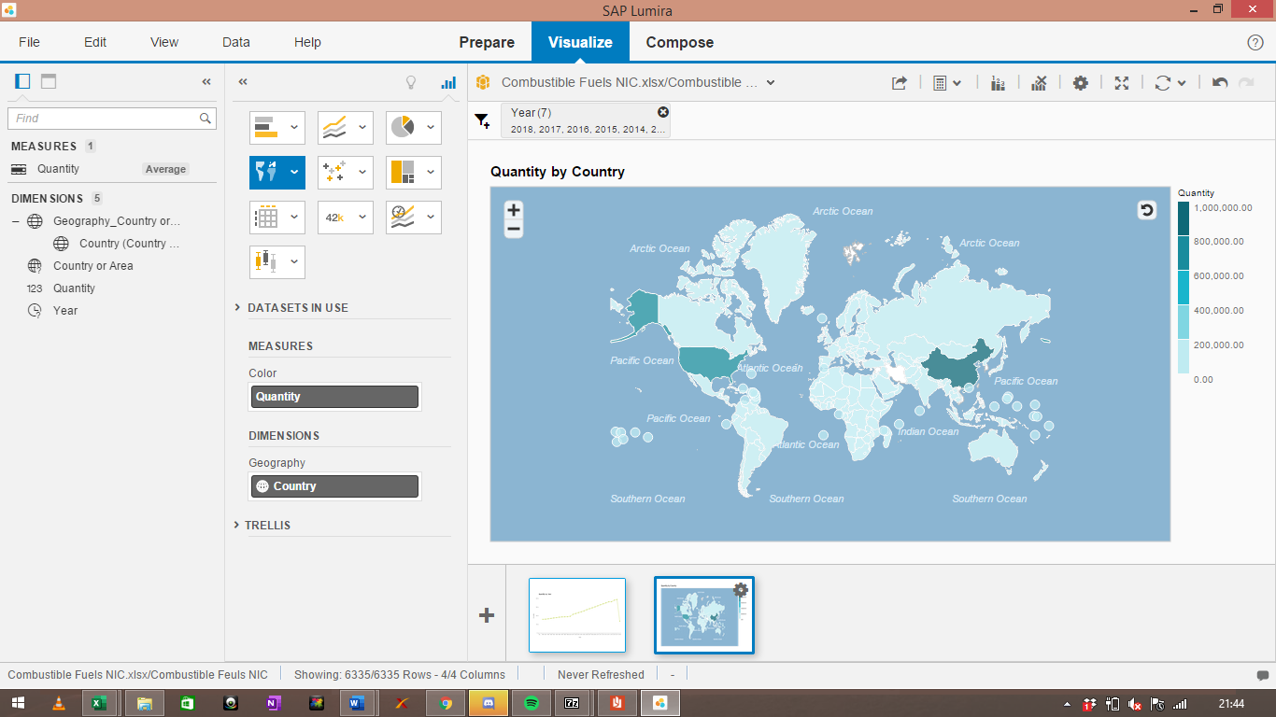

In the above map, we can see the scale on the right-hand side using sequential blue. Evidently, China and USA have the highest average net installed capacity for combustible fuels, followed by Russia and India. 200+ countries are still relying on combustible fuels for their energy requirements, which is extremely polluting and harmful. To have a clearer picture, we see the following tree map:

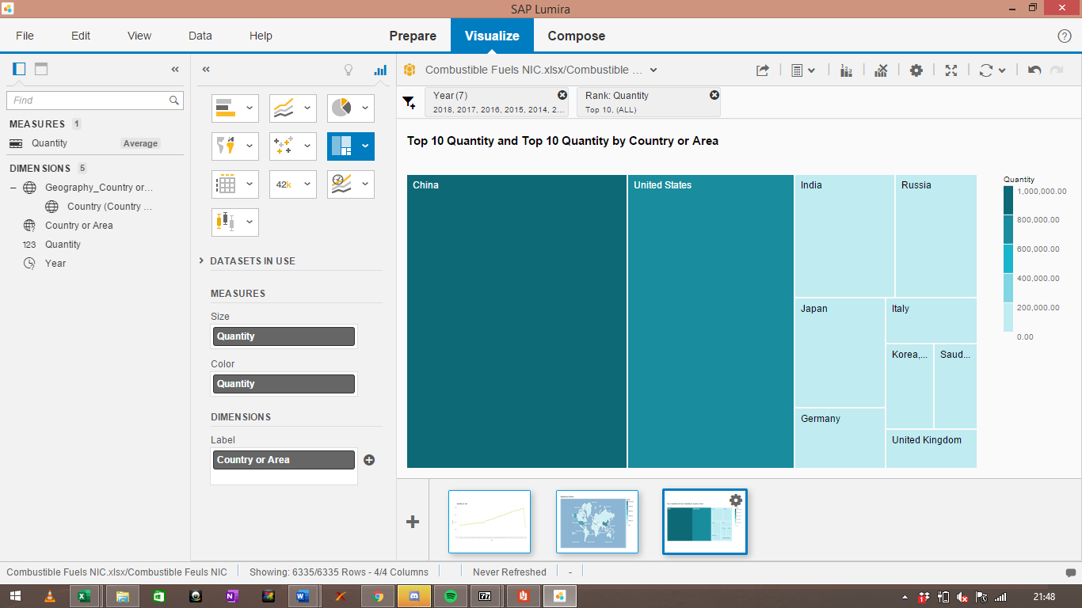

The above tree map displays the top 10 countries in terms of average net installed capacity for combustible fuels. We see that China ranks first, followed by US, Russia, and India. China has an average net installed capacity of 991,000 thousand kilowatt. These results show that even though the overall trend for combustible fuels has gone down, there is still work to do to move towards cleaner energy usage.

## 6.3 Nuclear Power

Generating electricity through nuclear power plants gained popularity in the 1980s and 1990s. However, only 34 countries in the world possess the technology to harness energy from fission or nuclear power plants. It is an effective and efficient mode, but is also expensive. To see the trend of nuclear power, we look at the following plot:

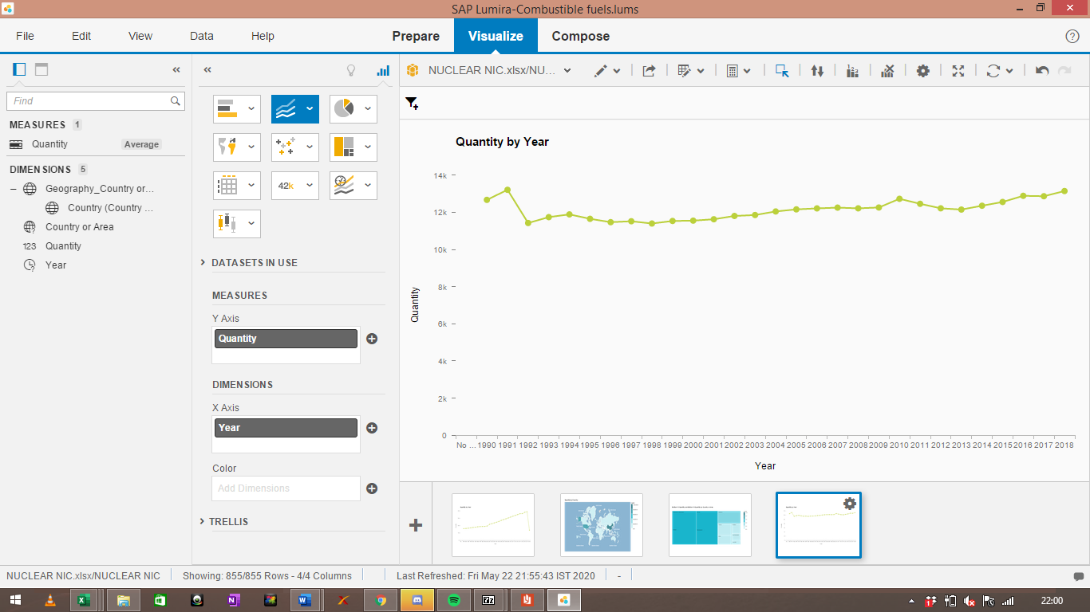

Evidently, we see that the trend has been somewhat stagnant and stable. There has not been much development and increase in the demand and supply and nuclear powerplants, nor has there been any obstacle to destabilize this trend. There are many restrictions associated with this method of power generation, since very few countries posses the technology to harness nuclear power. However, more and more countries are joining the race in terms of adoption of nuclear technology for power generation. We now focus on cross country analysis:

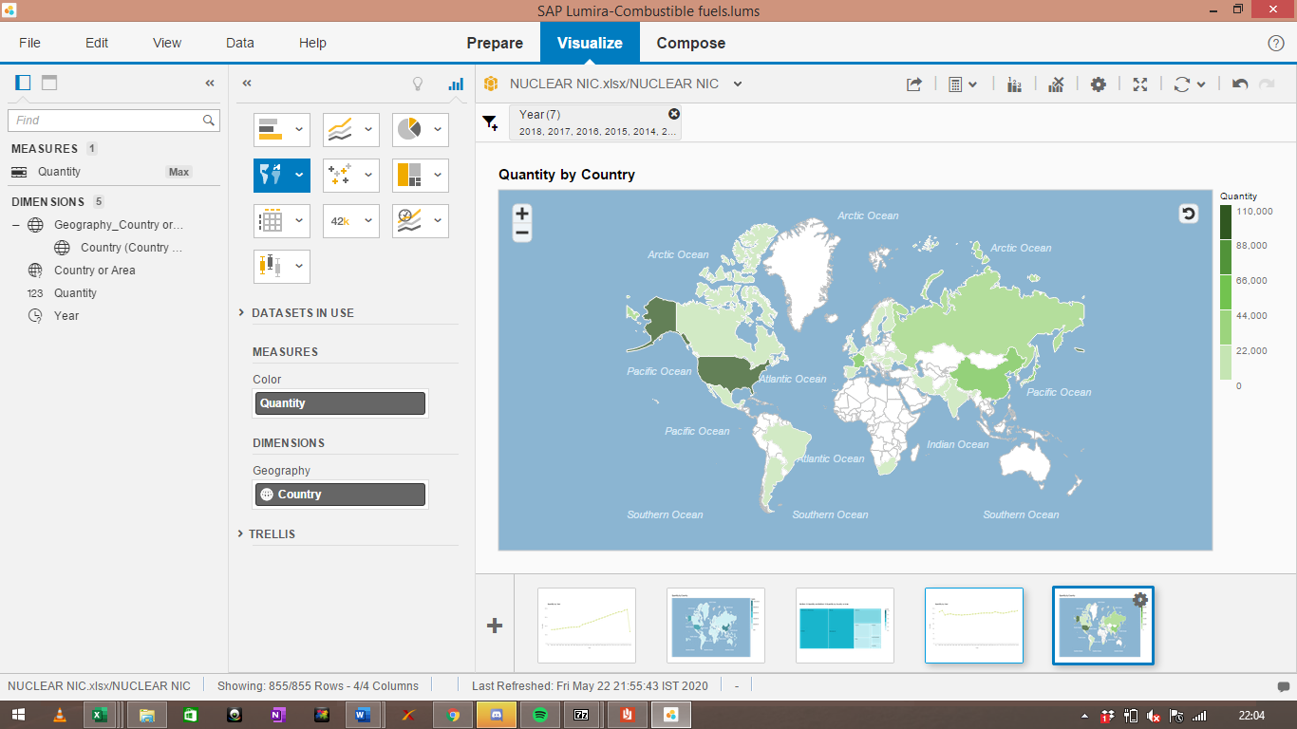

The map above plots the net installed capacity of nuclear power plant for 34 countries. We see that US has the highest net installed capacity of nuclear power, followed by China, Russia, Germany and France. This shows that only developed and rich countries are able to afford and use nuclear technologies as a source of power generation. To get a better picture, we refer to the following tree map:

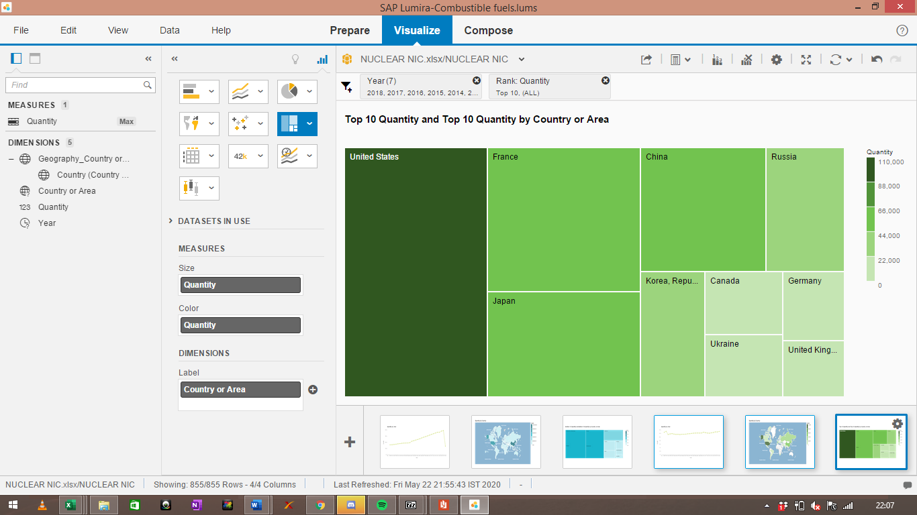

We see that US leads the race on nuclear power, with 101,000 thousand kilowatt, followed by France, Japan and China. India still lacks in the area of nuclear power, but is catching up. The analysis only includes 34 countries since these are the only countries which possess the technology to harness electricity from fusion.

## 6.4 Geothermal Power

Geothermal energy is the process of generating electricity using the heat from the inside of the earth. This type of technology can only be used in areas which are tectonically active regions, since only these places possess the temperature requirements. The trend in its net installed capacity can be seen as follows:

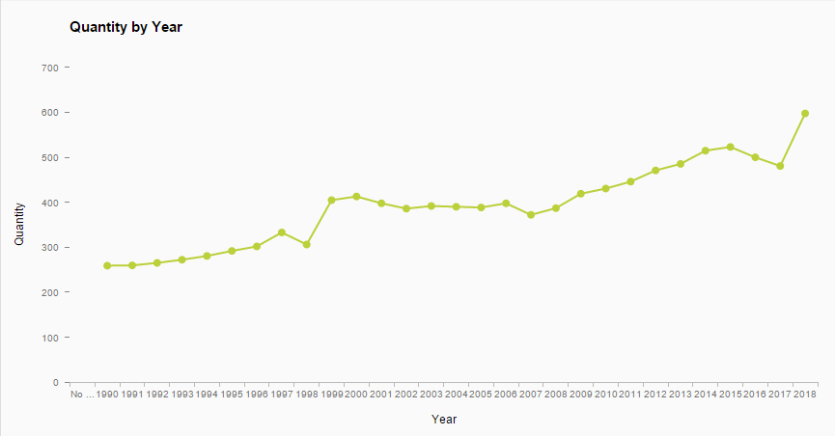

The line chart above shows that the net installed capacity for geothermal energy has been on an upward trend since 1980, and has gained major momentum in the past few years. We see a sharp increase in the year 2018 and 1999. However, there is not much untapped potential in the area of Geothermal energy, since geographic restrictions remain. Cross – country analysis shows:

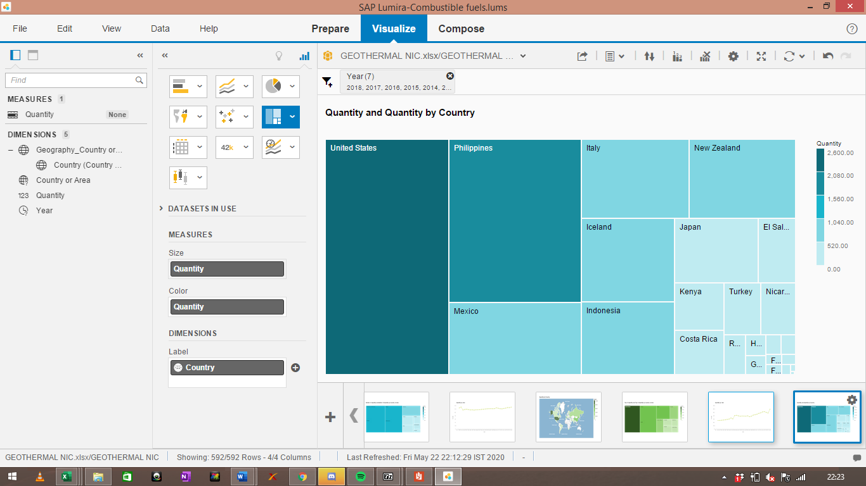

The tree map above shows that United States leads the race for Net Installed Capacity for Geothermal Energy, followed by Philippines, Mexico, Italy and so on. There are restrictions associated with geothermal energy as well, since the geographical location of the countries depend on the effectiveness of this method. Thus, not many countries are able to harness this method.

Finally, we now plot the trend of Solar, Nuclear and Geothermal Energy to compare the demand and supply of each, as follows:  
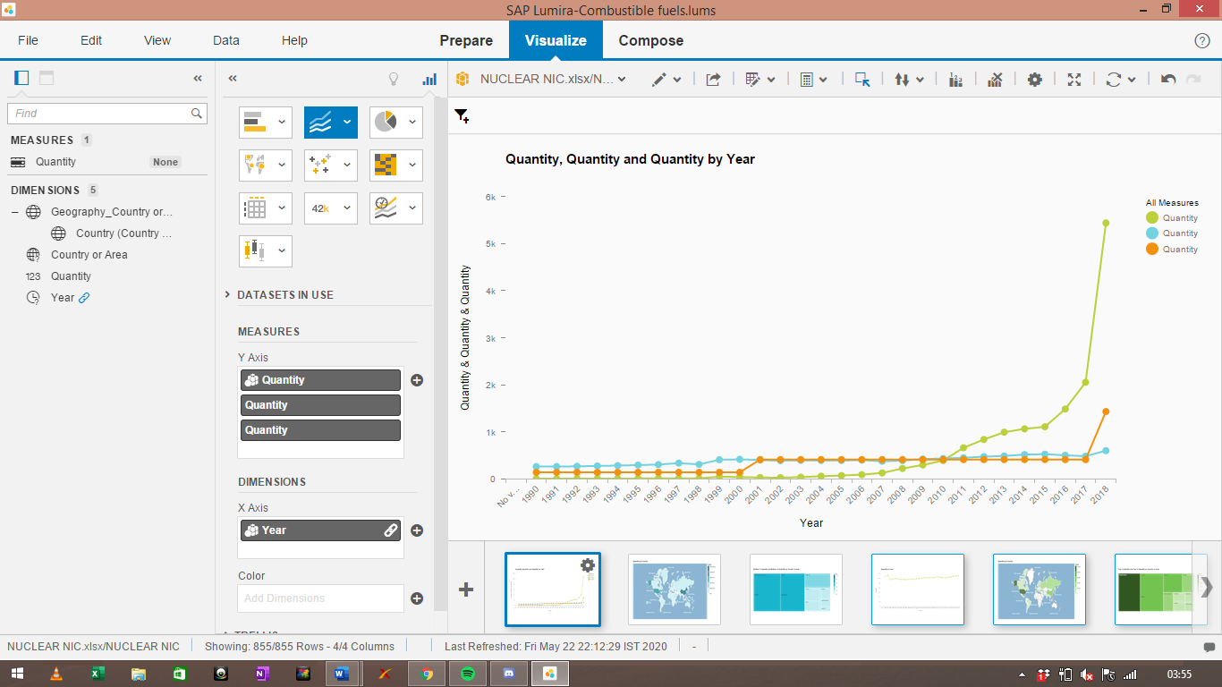

In the above graph, blue line represents geothermal net installed capacity, green line represents solar net installed capacity and red line represents nuclear net installed capacity. We see that Solar tends to have the highest level of net installed capacity around the world, while geothermal has the lowest. Solar energy has only recently picked up the pace, wherein it over took the geothermal and nuclear trends in 2011, and a sharp rise in 2018. Similarly, nuclear energy shows a steep rise in the year 2018 as well.

# Discussion

Looking at the results obtained above, we see that solar power very high in demand all over the world. There was a sharp increase in the level of net installed capacity of solar power plants after the year 2016. This is due to the fact of an increased demand for cleaner environment friendly modes of power generation. China appears to have the highest net installed capacity as compared to the rest of the world.

Looking at trends in combustible fuels, we see a sharp decline in the year 2018. Combustible fuels are harmful for the environment, thus countries and organisations are trying to switch to other ways to generate power, like solar, geothermal, wind, nuclear, etc. This explains the decline in net installed capacity. Further, we see that China and USA have the highest levels of average net installed capacity, followed my India, Russia, Japan and so on.

Geothermal and Nuclear energy have a stable growth rate throughout the years. However, very few countries posses the potential to harness such technologies. There is still a lot of untapped potential in these industries. Philippines has one of the largest net installed capacity for Geothermal energy, mainly because of its geographical location, which not many countries in the world enjoy.

Lastly, we see that Solar power has the highest net installed capacity among all three of the power generators. Nuclear Power is also picking up pace after 2018. As countries and organisations shift towards cleaner sources, we see a sharp rise in net installed capacities of nuclear and solar power plants. Solar power plants have a higher rise than nuclear since nuclear is relatively more expensive. Geothermal energy can only be harnessed in tectonically active regions, and thus not much progress has been made in this area.

# Conclusion

The above report provided useful insights into the trends of the energy sector, which can be used by policy makers all around the world. We see that solar energy has gained significant momentum along with nuclear energy, while combustible fuels seem to be losing momentum. Geothermal energy has a stable growth rate, mainly due to restrictions. There is still a lot of work to do to shift towards cleaner resources and abandon pollution sources like combustible fuels completely. Countries like India, China and US are still using combustible fuels to a great extent. This needs to change as soon as possible, and a smooth shift needs to come about from harmful sources to cleaner, greener sources. The problem of climate change is the problem of the hour, and we need to address it and tackle it by going as clean as possible.

# Recommendations

Looking at the findings, the researchers provide the following recommendations for the future:

1. Solar and Nuclear power should be given more importance than less cleaner forms like combustible fuels. Solar panels should be placed and electric cars should be made abundant.
2. Countries like China and US are still using combustible fuels to a great extent. Restrictions should be imposed on these countries to ensure a smooth switch towards cleaner modes of power generation.
3. Due to restrictions in nuclear and geothermal power plants, other ways like wind, hydro, etc can be used to generate power.

# Future Scope

Due to time constraints, the author did not consider other sources like wind energy, hydro energy, etc. These sources and data can also be considered in any future studies. Moreover, a vast number of business intelligence techniques can used on the dataset for a better understanding. A data quality management technique can be employed to ensure that the data for each of these sources is clean and usable.

# References

2U. (2019). *10 Key Benefits of Business Intelligence Software*. Retrieved from 2u, inc: https://www.mastersindatascience.org/resources/benefits-of-business-intelligence/

Adair, B. (2016, June 12). *Benefits of Business Intelligence Software*. Retrieved from Selecthub.com: https://www.selecthub.com/business-intelligence/business-intelligence-software-benefits/

Bhattar, P. (2019). *Energy: Intelligence and Efficiency*. Retrieved from Wartsila.com: https://www.wartsila.com/twentyfour7/energy/5-trends-that-will-shape-the-energy-sector-in-2020

Durcevic, S. (2019, November 28). *Top 10 Analytics And Business Intelligence Trends For 2020*. Retrieved from Datapine.com: https://www.datapine.com/blog/business-intelligence-trends/

Frankenfield, J. (2019, June 23). *BI*. Retrieved from Investopedia.com: https://www.investopedia.com/terms/b/business-intelligence-bi.asp

Kumar, S. (2019, November 25). Retrieved from Towardsdatascience.com: https://towardsdatascience.com/advantages-and-disadvantages-of-artificial-intelligence-182a5ef6588c

Micro Strategy. (2017). *BI: The Definitive Guide*. Retrieved from Microstrategy.com: https://www.microstrategy.com/us/resources/introductory-guides/business-intelligence-the-definitive-guide

Panintelligence. (2017). *Business Intelligence and Sports*. Retrieved from Panintellignec.com: https://www.panintelligence.com/resources/blog-posts/learning-from-the-past-business-intelligence-and-sport/

Pratt, M., & Fruhlinger, J. (2019, October 16). *What is business intelligence? Transforming data into business insights*. Retrieved from Cio.com: https://www.cio.com/article/2439504/business-intelligence-definition-and-solutions.html

Rai, R. (2019). *Top 6 Business Intelligence And Analytics Trends For 2020*. Retrieved from Polestar.com.

Rangaiah, M. (2018). *Role of Business Intelligence in the Sports Industry*. Retrieved from Analyticssteps.com: https://www.analyticssteps.com/blogs/role-business-intelligence-sports-industry

sesame. (2017, November 20). *he wave of Business Intelligence in Banking is here!* Retrieved from Sesameindia.com: https://www.sesameindia.com/blog/business-intelligence-banking-trends/

Strain, M. (2020). *The Advantages of Business Intelligence*. Retrieved from Chron.com: https://smallbusiness.chron.com/advantages-business-intelligence-24548.html

tableau. (2019, February 5). *What is business intelligence? Your guide to BI and why it matters*. Retrieved from tableau: https://www.tableau.com/learn/articles/business-intelligence

Ward, P., Windt, J., & Kempton, T. (2019). Business Intelligence: How Sport Scientists Can Support Organisation Decision Making in Professional Sport. *International Journal of Sports psyiology and performance*.

# 